**WayWord Connections**

(July 29, 2024)

*Connect Waypoints, Spell Out Your Trails, Map a Victory!*

**WayWord Connections** is a cooperative word game that combines spelling with strategic route building. Players work together to connect words of their choice with waypoints on their configurable map. For one to six players, aged 7+.

Cover all the waypoints with matching letters, then connect them all together by forming meandering paths of words, all before time runs out.

**Game Components:**

* 8 or 12 Magnetic Map Sections
* Magnetic Underlays (to connect the sections)
* 6 Danger Zone Cards
* 12 Word Category Cards
* 28 Assignment Cards
* 200 Letter Tiles, including 40 bigram & trigram tiles and three bridge tiles.

*Not included*: a timer. Use your cell phone to set a predetermined time limit (see below).

**Setup:**

1. Grab two or more random map sections, at least two sections per player. The more sections, the more challenging your game.
2. Form a map by arranging the sections in any orientation, connecting the sections with the magnetic underlays. Hundreds of configurations are possible.
3. Shuffle the danger zone cards and place face down over random locations on the map. You only need one card per pair of map sections. Flip these over and keep only those marked as dangers. Discard the rest.
4. Scatter all the letter tiles face up around the map within reach of all players.
5. Shuffle the two sets of category and assignment cards and give each player one of each type.
6. Set your timer to 16 minutes per section divided by the number of players, so if you have eight sections and four players, set the timer to 16 x 8 / 4 = 32 minutes.

**Goal:** Cover all the waypoints and connect them with words such that no waypoint is isolated, creating meandering paths of letters. Complete your assignments. Do this before time runs out for the victory!

**Sample Board Layouts:**

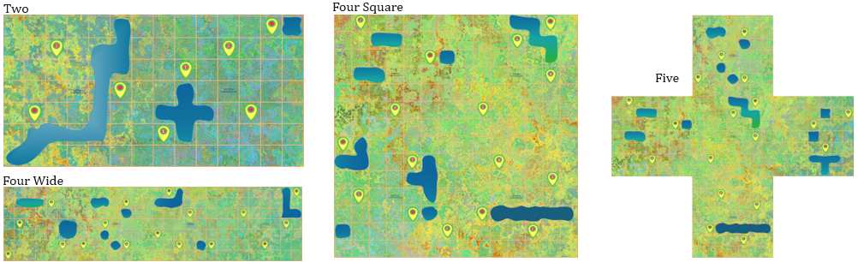 **Game Play:**

*You are all playing against the clock, and all at the same time.*

1. Players take ten letter tiles from the draw pile as a “hand”.
2. Players place tile(s) in one of four ways:

* On top of a waypoint with its matching letter or
* Any letter on a blank waypoint A map with a red circle

  Description automatically generated or
* Adjacent to an existing letter to form a new word.
* Appended to an existing word to for a new word.

1. Join two words across a common letter (crossword).
2. Replace the tiles in your hand to a maximum of ten tiles.
3. Play until all waypoints are covered and all words are interconnected.

**Letter Placement Rules:**

A letter tile must fit within a grid square.

You may place a word across available squares, but to complete the game, a word cannot be orphaned (unconnected).

To cross a large body of **water**, you must first place an available bridge over the water square, cover it with a letter in your word and complete the word.

To use a **boardwalk**, the entire word must cover and follow the path in the same direction. In other words, you cannot cross a boardwalk, you must follow it and in some cases in the direction of the arrow. Boardwalks act as barriers in the sense you cannot make a word across, only following it.

Once a complete word has been placed, it may not be removed. However, you may add letter(s) to it as long as a new valid word is created. This is often the case when appending a letter to the end of a word with a crossed word. Swapping of letters is only allowed when making a new word. Replace a needed letter from one word with another letter and use the taken letter in a new word.

Stacking of a letter is allowed to form a crossed word, with two new words being made.

The **orientation & direction** of words does not matter as long as the letters are in the correct order to make a valid word. Here are some examples …

|  |  |
| --- | --- |
|  | There are seven valid words in this example with different orientations and directions. All are validly placed.  NOODLES, LEAF, FIXER, NEATER, TOO, NEATER, TEAM (or MEAT). |

**Assignments:**

Using their category and assignment cards, each player will have a type of word to make. Make these words early to take advantage of all letters being available. Sample assignments:

|  |  |
| --- | --- |
|  | CANYON CLIFFS  BOSTON BORDER |
|  | BEAR MOLE VOLE  DEER TOAD DOVE |

**Ending the Game:**

The game ends when all the waypoints are covered and all words are connected, as long as time has not run out. As well, all players must have completed their assignments. Ensure all words are valid and work together to beat the clock!

**Expert Challenge Mode:**

Setup with all tiles upside down. Each player maintains seven tiles, drawing from the draw pile as needed. If you cannot make a word, wait until another player drops a word. Otherwise, replace all tiles.

**Scoring Mode:**

Optionally, count the number of letters remaining once the timer expires. Attempt to get the lowest score by playing the same layout twice.

|  |  |
| --- | --- |
|  | ***POST A PHOTO OR VIDEO***  Post your group playing the game on Instagram with the #waywordconnections and @brainy.games. We’ll mail you a free memory game as thank you gift. |

Copyright © 2024 Knowledge Probe Inc. (dba) [www.Brainy.gam](http://www.Brainy.gam)[es](http://www.brainy.games/)